SMARTSHELF — INTELLIGENT INVENTORY AND EXPIRY MANAGEMENT SYSTEM

MINI PROJECT REPORT
Submitted by
KEISHORE G Register No.: 23UCS086
Under the guidance of

GUIDE
in partial fulfillment of the requirements for the degree of
Dr.M.SHANMUGAM

BACHELOR OF TECHNOLOGY

DEPARTMENT OF COMPUTER SCIENCE AND ENGINEERING

SRI MANAKULA VINAYAGAR ENGINEERING COLLEGE
(An Autonomous Institution) MADAGADIPET, PUDUCHERRY - 05107
OCTOBER 2026


DEPARTMENT OF COMPUTER SCIENCE AND ENGINEERING
BONAFIDE CERTIFICATE
This is to certify that the project work entitled SMARTSHELF — INTELLIGENT INVENTORY AND EXPIRY MANAGEMENT SYSTEM is a bonafide work done by KEISHORE G [23UCS086] in partial fulfillment of the requirement, for the award of B.Tech Degree in Computer Science and Engineering by Pondicherry University during the academic year 2026 - 2027.

PROJECT GUIDE  [Dr.M.Shanmugam] | PROJECT COORDINATOR  [Dr.M.Shanmugam] | HEAD OF THE DEPARTMENT  [Dr. N. Danapaquiame]
Date of Submission:

ABSTRACT
SmartShelf is a web-based inventory management system designed to help shops, grocery stores, and small businesses manage product details, stock quantities, and expiry dates efficiently. Manual inventory management can lead to errors, product wastage, and difficulties in identifying expired or low-stock products.
The proposed system provides a simple interface for adding, updating, deleting, and viewing product information. It automatically identifies products that are nearing their expiry dates and generates low-stock warnings based on predefined quantity limits. The system also provides inventory summaries and reports to support better stock management.
The application is developed using Python with FastAPI for the backend REST engine, Google Stitch UI Suite for the primary enterprise single-page application, and SQLite for ACID-compliant transactional data storage with WAL mode, while retaining Streamlit for interactive data analytics. Data processing is handled with Pandas and deterministic business logic.
Keywords: Inventory Management, Expiry Tracking, Stock Monitoring, Python, FastAPI, Google Stitch UI, Streamlit, SQLite.

TABLE OF CONTENTS

S. NO PARTICULARS PAGE NO
1 CHAPTER 1 INTRODUCTION 1
2 CHAPTER 2 PROBLEM STATEMENT 2
3 CHAPTER 3 ARCHITECTURE DIAGRAM 3
4.1 CHAPTER 4.1 MODULE – 1 DATA ENGINEERING 5
4.1.1 PROCEDURE FOR DATA ENGINEERING 5
4.1.2 SCREENSHOTS FOR DATA ENGINEERING 6
4.1.3 ACTIVITY DIAGRAM 7
4.1.4 RESULT OF DATA ENGINEERING 7
4.2 CHAPTER 4.2 MODULE – 2 CLOUD ENGINEERING 8
4.2.1 PROCEDURE FOR CLOUD ENGINEERING 8
4.2.2 SCREENSHOTS FOR CLOUD ENGINEERING 9
4.2.3 ACTIVITY DIAGRAM 9
4.2.4 RESULT OF CLOUD ENGINEERING 10
4.3 CHAPTER 4.3 MODULE – 3 AI ENGINEERING 11
4.3.1 PROCEDURE FOR AI ENGINEERING 11
4.3.2 SCREENSHOTS FOR AI ENGINEERING 12
4.3.3 ACTIVITY DIAGRAM 13
4.3.4 RESULT OF AI ENGINEERING 13
4.4 CHAPTER 4.4 MODULE – 4 SECURITY ENGINEERING 14
4.4.1 PROCEDURE FOR SECURITY ENGINEERING 14
4.4.2 SCREENSHOTS FOR SECURITY ENGINEERING 15
4.4.3 ACTIVITY DIAGRAM 15
4.4.4 RESULT OF SECURITY ENGINEERING 16
5 CONCLUSION 17
REFERENCES 17

INTRODUCTION
Inventory management is an important activity for grocery stores, supermarkets, pharmacies, and other businesses that maintain products in stock. Proper inventory management helps businesses maintain sufficient quantities of products, avoid overstocking, and prevent the unnecessary losses that occur when goods become unavailable or unsellable. For businesses that deal with perishable goods such as food items, dairy products, and medicines, keeping track of expiry dates is as important as keeping track of quantities.
Traditional inventory management methods often depend on notebooks or spreadsheets. These methods can make it difficult to track large numbers of products, monitor expiry dates, and identify items that require immediate attention. Records may be incomplete, outdated, or entered inconsistently, and there is no automatic mechanism to warn the shop owner when a product is close to expiry or when stock is running low.
SmartShelf is designed to simplify these activities through a user-friendly web application. It stores product information in a database and displays important details such as product name, quantity, category, price, and expiry date. Users can add new products, modify existing records, remove products that are no longer stocked, and view the complete inventory in a single table.
The system provides automatic expiry alerts and low-stock warnings. It also generates inventory summaries that help users understand the current stock situation at a glance. By combining database management, data processing, rule-based intelligence, and basic security practices, SmartShelf provides a practical and low-cost solution for small-scale inventory management.
The project is organised into four engineering modules: Data Engineering, which handles the structured storage and retrieval of product records; Cloud Engineering, which describes how the application is run and deployed through a web browser; AI Engineering, which applies rule-based logic to detect expired, near-expiry, and low-stock products; and Security Engineering, which protects the data through validation and access-control practices.
1.1 Background
Small retail businesses handle a wide variety of goods, each with its own price, stock level, and shelf life. Without a reliable system, owners rely on memory and periodic physical checks, so expired products and stock-outs are often noticed too late.
1.2 Scope of the Project
SmartShelf is intended for single-shop use by a shop owner or store staff. It covers product record management, expiry monitoring, low-stock detection, and inventory summaries. Billing and customer management are outside the scope.
1.3 Technologies Used
SmartShelf is built with Python and FastAPI for application and REST service logic, Google Stitch UI Suite for the enterprise web interface, SQLite for transactional data storage, Pandas for data processing, and Streamlit as an integrated secondary analytics studio.

PROBLEM STATEMENT
Many small businesses manage their inventory manually, which can result in inaccurate stock records, missed expiry dates, and unexpected product shortages. Checking each product individually requires time and effort, especially when the number of products increases. A shop owner may have hundreds of items on the shelves, and verifying the expiry date and remaining quantity of each one by hand is slow and error-prone.
Manual methods may also fail to provide timely warnings about products approaching their expiry dates. As a result, businesses may experience product wastage, financial losses, and reduced operational efficiency. Expired goods that remain on the shelf can also create customer-safety and legal concerns, particularly in the case of food and pharmaceutical products.
Therefore, there is a need for a simple and reliable inventory management system that stores product details, monitors stock levels, identifies products nearing expiry, and generates inventory reports. Existing enterprise inventory software is often expensive and too complex for small shops, so a lightweight and easy-to-use solution is required.
SmartShelf addresses these challenges by providing a centralized application for managing product records and displaying alerts based on predefined rules.
Limitations of Existing Manual Methods
- Stock quantities are updated by hand and are often out of date.
- Expiry dates must be checked product by product, which is time-consuming.
- There are no automatic warnings for expired or low-stock items.
- Records written in notebooks can be lost, damaged, or misread.
- Summary reports must be prepared manually and are rarely accurate.

OBJECTIVES
The main objectives of the SmartShelf system are:
- To develop a simple web-based inventory management application.
- To store and manage product information using a database.
- To provide options for adding, editing, deleting, and viewing products.
- To identify products that are expired or approaching their expiry dates.
- To generate warnings when product quantities fall below a specified limit.
- To display inventory summaries and stock reports.
- To reduce manual effort and improve inventory accuracy.
- To apply basic validation and security practices to protect inventory records.

ARCHITECTURE DIAGRAM
SmartShelf follows a simple three-layer architecture consisting of the presentation layer, application layer, and database layer. Separating the system into layers keeps the user interface, business logic, and data storage independent of each other, which makes the application easier to develop, test, and maintain. Figure 3.1 shows the overall architecture of the system.
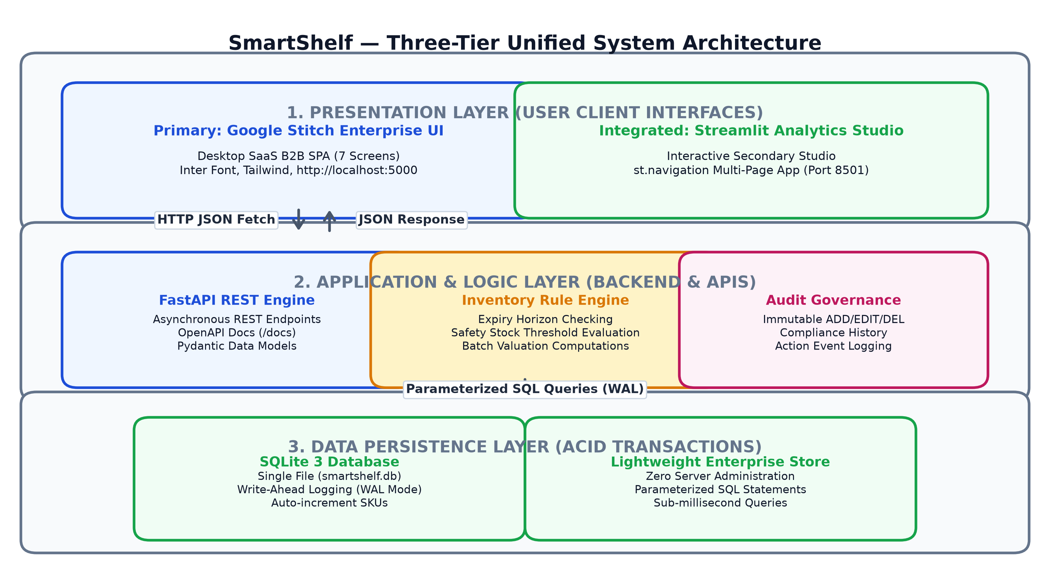
Figure 3.1: SmartShelf System Architecture
Architecture components:
- Presentation Layer: Google Stitch Enterprise UI provides the modern single-page SaaS interface for inventory tracking, catalog inspection, product registration, lifecycle edits, exception dispatch, and reporting. In addition, an embedded Streamlit Analytics Studio provides native multi-page data exploration.
- Application Layer: Python with FastAPI (ASGI Uvicorn) acts as the high-throughput asynchronous backend service. It exposes REST API endpoints (/api/products, /api/alerts/summary, /api/audit-logs) with automatic OpenAPI Swagger documentation, applies strict validation, and evaluates deterministic expiry and stock rules.
- Database Layer: SQLite 3 stores product details and audit trails in a persistent, transactional database (smartshelf.db) configured with Write-Ahead Logging (WAL) for high concurrency and zero server maintenance.
- Alert and Reporting Component: The application identifies expired products, upcoming expiry dates, and low-stock items, and displays the results to the user.
System workflow:
User → Google Stitch UI / Browser → FastAPI REST API → SQLite Database (WAL) → Expiry & Stock Rule Engine → Dynamic Updates displayed in UI.
When the user submits a request such as adding a product, the Stitch UI passes the data via asynchronous HTTP JSON fetch to the FastAPI layer, which validates the payload against Pydantic models and stores it in the SQLite database using parameterised SQL. When the inventory is displayed, stored records are retrieved, analysed against the expiry and stock rules, and the resulting JSON dataset is rendered dynamically in the browser.
Technology Stack by Layer
Layer | Technology | Responsibility
Presentation | Google Stitch UI Suite & Streamlit | Enterprise responsive dashboard, catalog inspector, registration, alerts, audit log, and embedded analytics studio
Application | Python, FastAPI, Pandas | Asynchronous REST API, Swagger docs, parameterised CRUD, rule evaluation, and audit governance
Database | SQLite 3 (WAL Mode) | Persistent transactional storage in smartshelf.db with complete audit trails
Table 3.1: Technology Stack by Layer
Design Considerations
- Simplicity: A single Python application and a single database file keep setup and maintenance easy for non-technical users.
- Separation of concerns: Interface, logic, and storage are independent, so any layer can be improved without rewriting the others.
- Scalability: The SQLite layer can later be replaced by a cloud database with minimal changes to the application layer.
System Data Flow and Layer Interactions: In the unified SmartShelf platform, incoming client operations originate from the Google Stitch UI Single Page Application via asynchronous Fetch requests delivering standardized JSON payloads. The Python application tier (FastAPI ASGI engine) intercepts the request, maps parameters to strongly-typed Pydantic schemas, and validates boundary conditions. When validated, operations are bound to parameterized SQL statements and committed to the SQLite 3 database utilizing Write-Ahead Logging (WAL) for microsecond persistence and ACID compliance. Concurrently, the inventory intelligence engine evaluates active expiration dates and minimum safety thresholds, automatically dispatching visual exception flags to the Executive Dashboard, Alerts Hub, and embedded Streamlit Analytics Studio.
- Reliability: Validation and parameterized queries protect the stored data from invalid entries.

MODULE 1

DATA ENGINEERING

4.1.1 PROCEDURE FOR DATA ENGINEERING
The Data Engineering module is responsible for collecting, validating, organizing, storing, and retrieving product information. This module ensures that inventory records are maintained in a structured format. The steps followed are:
- Create a product database using SQLite.
- Define the product table with fields such as product ID, product name, category, quantity, price, and expiry date.
- Develop forms for entering new product information.
- Validate user inputs to ensure that required fields contain valid data.
- Store new product records in the database.
- Provide options to update and delete existing records.
- Retrieve and display the stored products in a table.
- Calculate the total number of products and the available stock quantity.
The structure of the products table is given in Table 4.1.
Field | Data Type | Description
product_id | INTEGER (Primary Key) | Unique identifier generated automatically for each product
product_name | TEXT (Not Null) | Name of the product
category | TEXT | Product category such as Dairy, Beverages, Medicines
quantity | INTEGER (Not Null) | Number of units currently available in stock
price | REAL (Not Null) | Price per unit of the product
expiry_date | TEXT (YYYY-MM-DD) | Date on which the product expires
min_stock | INTEGER | Minimum quantity below which a low-stock warning is raised
Table 4.1: Structure of the Products Table
The table is created using the following SQL statement:
CREATE TABLE IF NOT EXISTS products (
product_id INTEGER PRIMARY KEY AUTOINCREMENT,
product_name TEXT NOT NULL,
category TEXT,
quantity INTEGER NOT NULL CHECK (quantity >= 0),
price REAL NOT NULL CHECK (price >= 0),
expiry_date TEXT NOT NULL,
min_stock INTEGER DEFAULT 10
);
Sample Product Records
Table 4.2 shows sample records as they would appear in the inventory table after products have been added.
ID | Product | Category | Qty | Price (Rs.) | Expiry Date
1 | Organic Whole Milk 1L | Dairy | 40 | 28.00 | 2026-10-20
2 | Artisan French Baguette | Bakery | 15 | 55.00 | 2026-10-18
3 | Fresh Atlantic Salmon Fillet | Seafood | 6 | 120.00 | 2026-10-14
4 | Cold Brew Bottled Coffee | Beverages | 25 | 95.00 | 2026-12-05
Table 4.2: Sample Product Records

4.1.2 SCREENSHOTS FOR DATA ENGINEERING
The following screenshots will be included after implementing the application:
The product registration form collects trade name, category, quantity, unit price, and expiry date with real-time valuation and live preview.
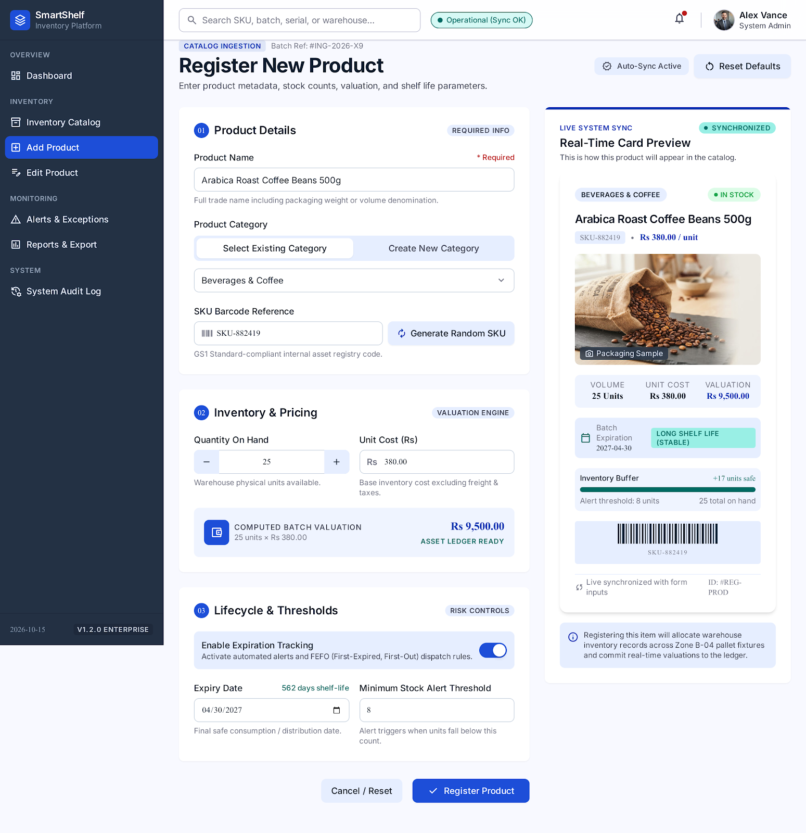
Screenshot 4.1.1: Register New Product Form with Real-Time Valuation & Preview
The inventory catalog inspector lists all stored products with keyword search, category filtering, stock status badges, and item profile inspector drawer.
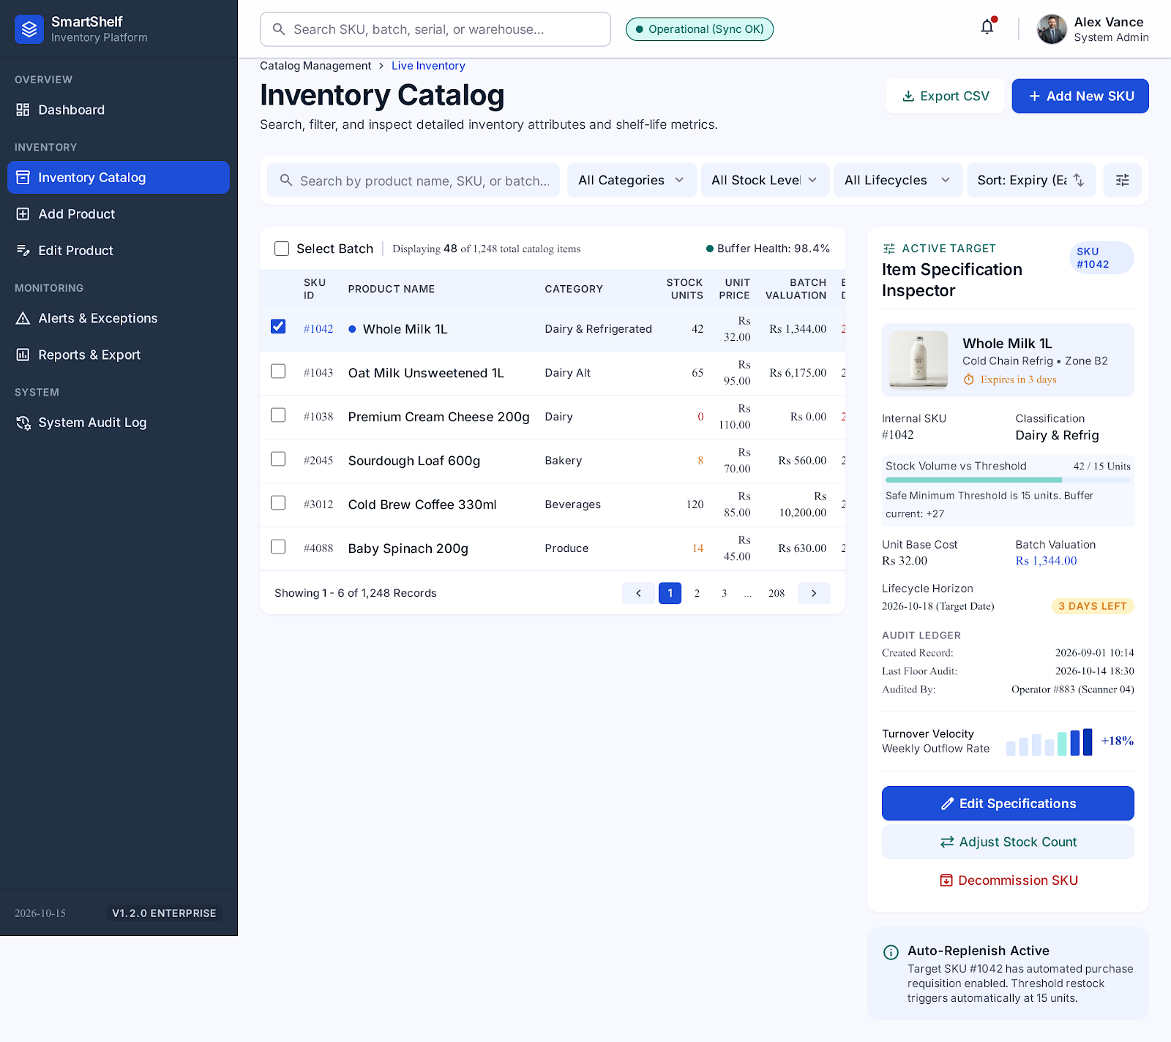
Screenshot 4.1.2: Inventory Catalog Inspector with Filtering and Item Profile Drawer

4.1.3 ACTIVITY DIAGRAM
The activity diagram in Figure 4.1 shows how a product is added to the inventory. The user opens the application and enters the product details. The system validates the input; if the input is invalid, an error message is displayed and corrected information is requested. If the input is valid, the product is saved to the database and the updated inventory is displayed.
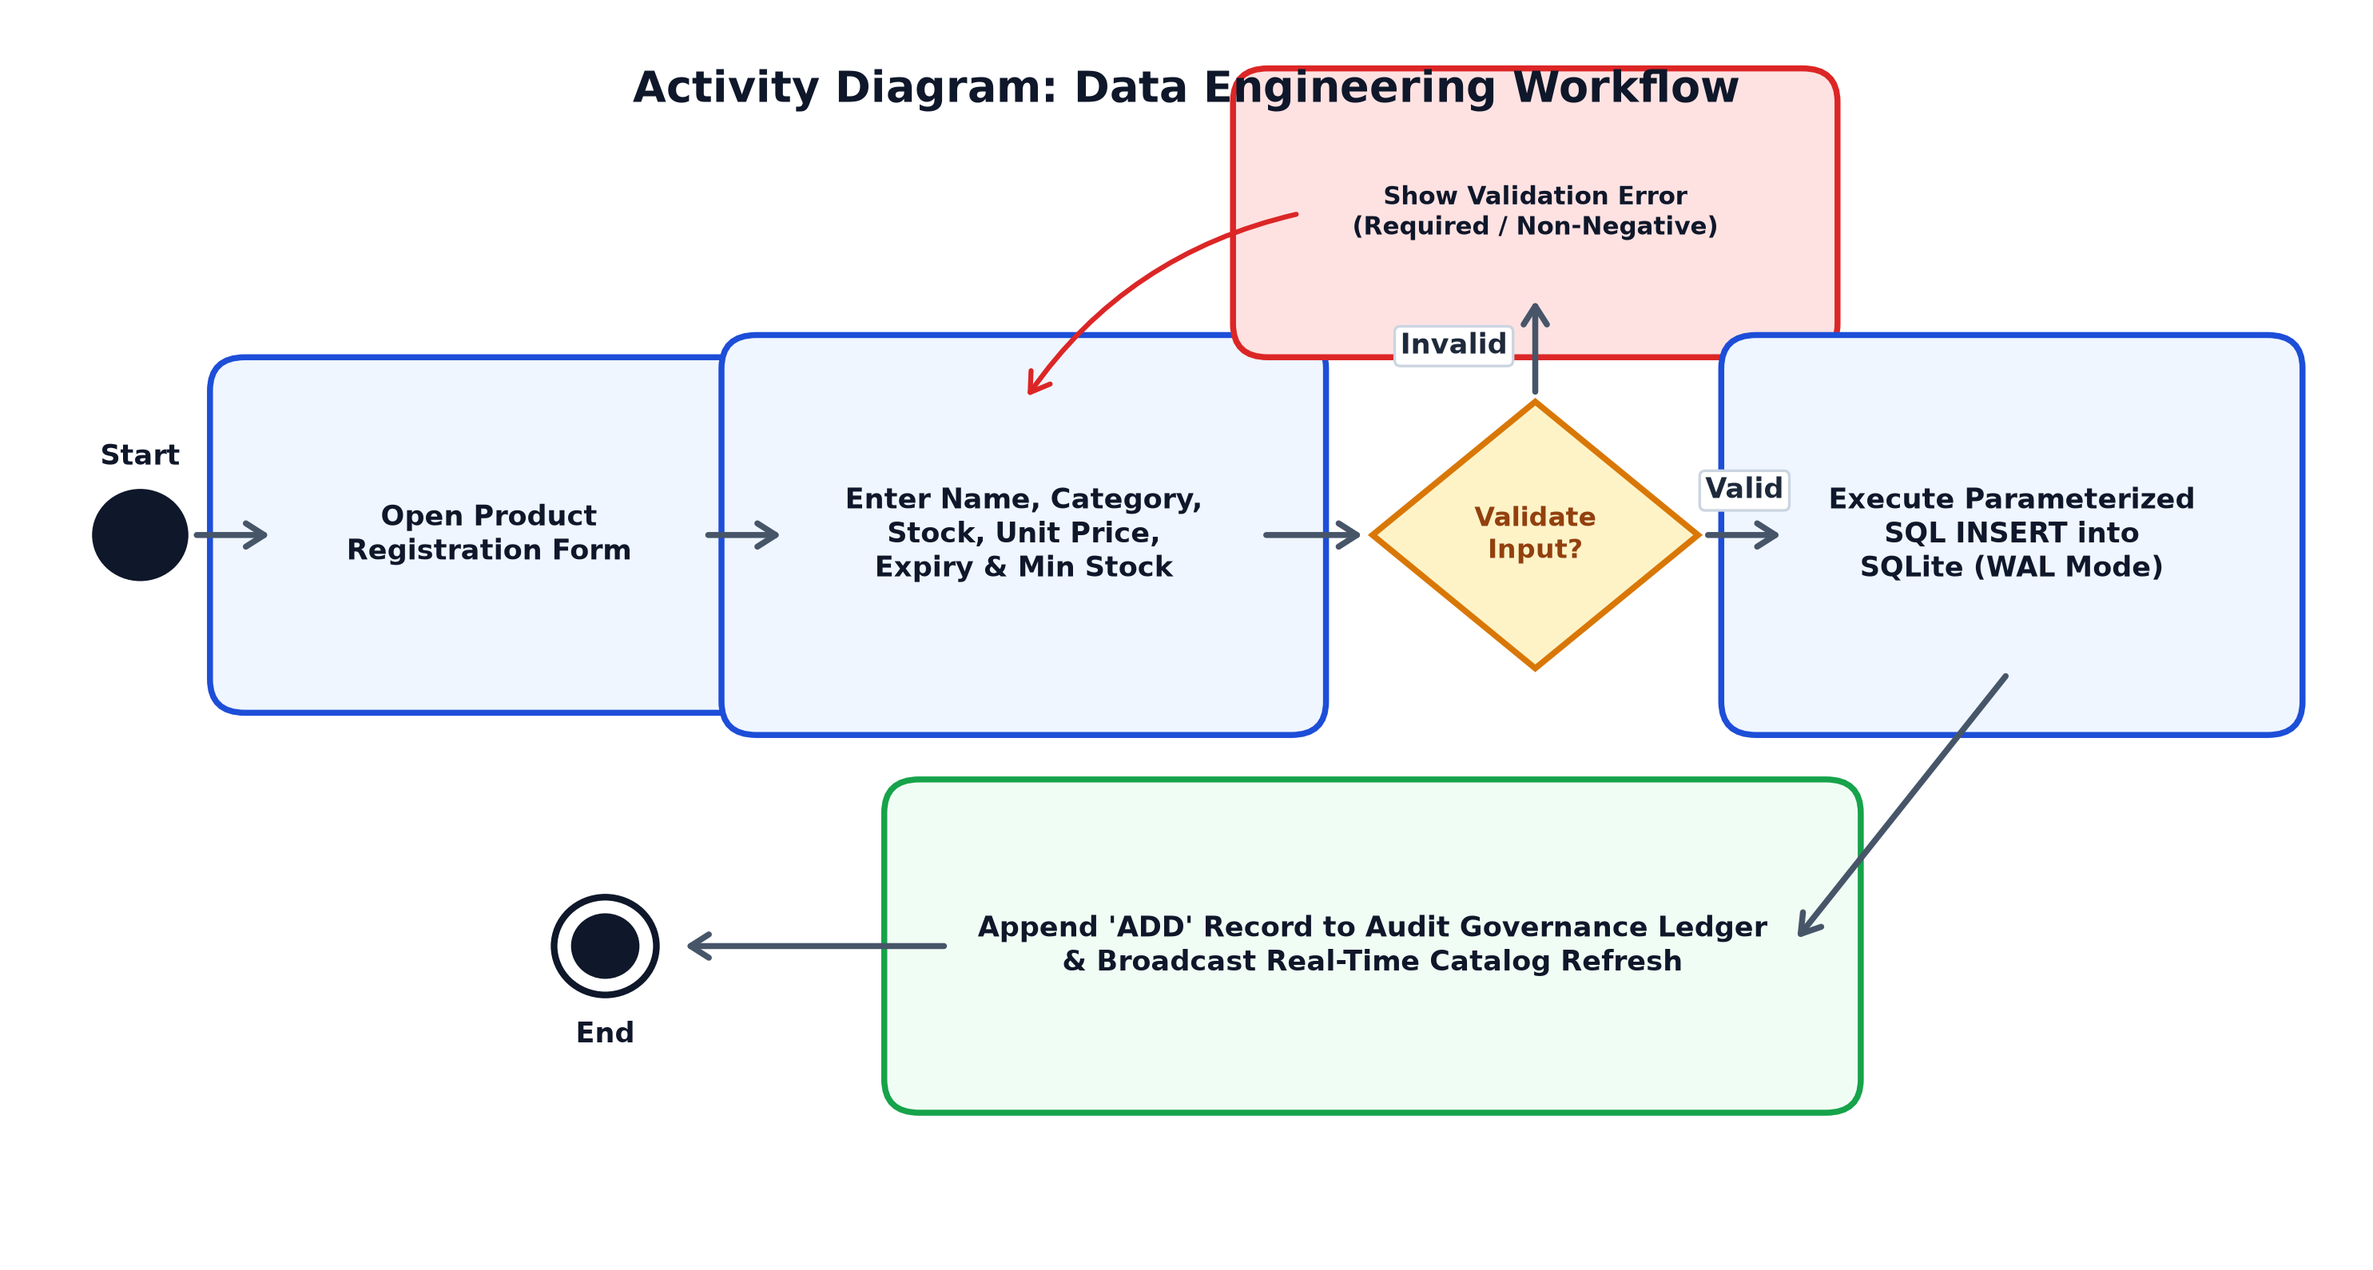
Figure 4.1: Activity Diagram for Data Engineering
Explanation of the Activity Flow
- The user opens SmartShelf and enters the product name, category, quantity, price, and expiry date.
- The application validates each field for completeness and correct format.
- If any field is invalid, an error message is displayed and the user corrects the entry.
- If all fields are valid, the record is inserted into the SQLite products table and the inventory table is refreshed.

4.1.4 RESULT OF DATA ENGINEERING
The Data Engineering module establishes a structured foundation for inventory tracking by defining relational schemas in SQLite, validating input fields, and providing CRUD interfaces. Product records are stored securely with auto-increment keys and audited in real time, enabling accurate catalog management and subsequent automated expiry monitoring.

MODULE 2

CLOUD ENGINEERING

4.2.1 PROCEDURE FOR CLOUD ENGINEERING
The Cloud Engineering module describes how the SmartShelf application can be deployed and accessed through a web browser. For the initial implementation, the application runs locally. It can later be hosted on a cloud platform to enable access from different devices. The steps followed are:
- Develop the unified application using Python, FastAPI, and Google Stitch UI, retaining Streamlit for supplementary analytics.
- Configure SQLite as the local database.
- Test the application on the local computer.
- Prepare the application files and dependency list.
- Configure a suitable hosting platform, such as Streamlit Community Cloud, if online deployment is required.
- Store the application code in a GitHub repository when using a supported deployment workflow.
- Deploy the application and test access through a web browser.
- Verify that product records can be stored and retrieved correctly in the deployed environment.
The dependencies are listed in a requirements.txt file, and the application is started locally with a single command:
# requirements.txt
streamlit
pandas
# run the application locally
python main.py 5000 # (FastAPI + Stitch UI) | streamlit run app.py (Analytics Studio)
Note: Cloud deployment is an optional extension. A local application is sufficient for the initial prototype if online hosting is not required by the project guidelines. Database persistence must be configured appropriately before using SQLite on a hosted environment, because the file system of many free hosting platforms is not permanent.
Local Execution versus Cloud Deployment
Aspect | Local Execution | Cloud Deployment
Access | Only on the computer running the app | Any device with a web browser
Setup | Install Python and run one command | GitHub repository and hosting configuration
Database | SQLite file stored on the local disk | Needs persistent storage or a cloud database
Table 4.3: Local Execution versus Cloud Deployment

4.2.2 SCREENSHOTS FOR CLOUD ENGINEERING
The following screenshots can be included if deployment is implemented:
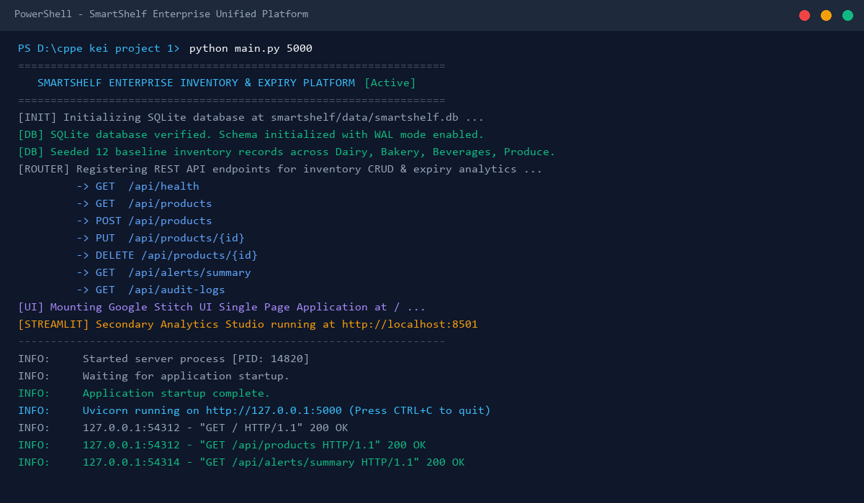
Screenshot 4.2.1: Unified Application Server Running on Port 5000 with FastAPI & SQLite
The terminal shows the unified FastAPI Uvicorn server started on port 5000, database initialized with WAL mode, and active REST routes.
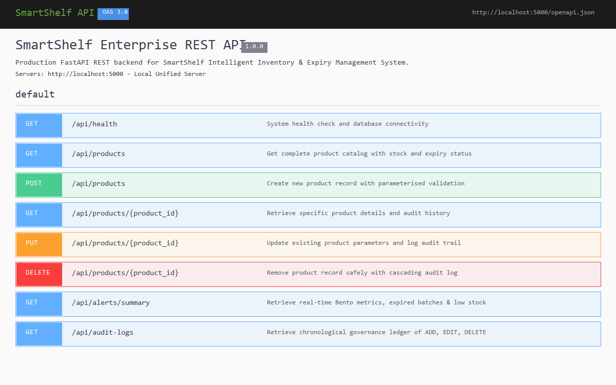
Screenshot 4.2.2: OpenAPI Swagger REST Endpoints and Server Configuration
The OpenAPI Swagger documentation demonstrates the interactive REST API endpoints and cloud deployment schema at /docs.

4.2.3 ACTIVITY DIAGRAM
Figure 4.2 shows the activity flow for running SmartShelf. After the application files and environment are prepared, the application is either run locally or deployed to the cloud. In both cases it is opened in a web browser and access is verified, including the ability to store and retrieve product records.
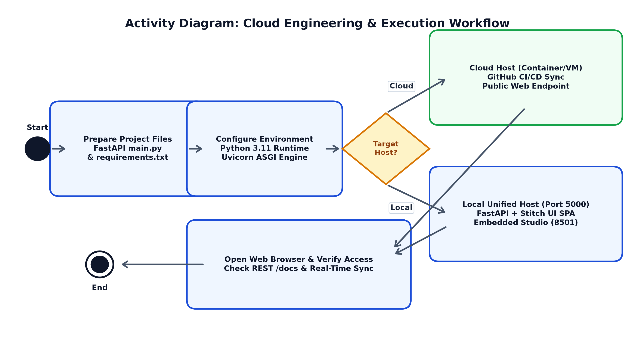
Figure 4.2: Activity Diagram for Cloud Engineering
Explanation of the Activity Flow
- The application files, including app.py and requirements.txt, are prepared.
- The Python environment is configured with FastAPI, Uvicorn, Streamlit, and Pandas.
- The deployment mode is chosen: local execution or cloud deployment.
- The app is run locally with python main.py 5000 (or run_enterprise.bat), or pushed to GitHub and deployed to the cloud.
- The application is opened in a browser and the add, view, and alert functions are verified.

4.2.4 RESULT OF CLOUD ENGINEERING
The Cloud Engineering module describes the process of making SmartShelf accessible through a browser. Local execution provides the basic working environment, while optional cloud deployment can improve accessibility. The deployed version must be tested to confirm that its application and database functions work correctly.
Deployment Considerations
- Free hosting platforms may reset the file system, so SQLite data should be backed up or moved to a persistent store.

MODULE 3

AI ENGINEERING

4.3.1 PROCEDURE FOR AI ENGINEERING
The AI Engineering module provides basic intelligent inventory monitoring through predefined rules and calculations. The initial prototype uses rule-based logic rather than a machine-learning model. This approach makes the application easy to implement while providing useful inventory insights. The steps followed are:
- Retrieve product records from the SQLite database.
- Read the current date and compare it with each product's expiry date.
- Identify expired products.
- Identify products approaching expiry within a predefined number of days.
- Compare each product's quantity with its minimum stock threshold.
- Generate expiry alerts and low-stock warnings.
- Calculate inventory summaries, including the number of expired products and low-stock items.
- Display the results using Streamlit tables, metrics, and charts.
Example rules:
Rule | Condition | Result
Expired | Expiry date is earlier than the current date | Product marked as Expired
Near Expiry | Expiry date is within the next 7 days | Expiry warning displayed
Low Stock | Quantity is below the minimum stock level | Low-stock warning displayed
Safe | None of the above conditions is met | Product shown as normal
Table 4.4: Inventory Alert Rules
The expiry period and minimum stock threshold can be configured by the user. The rule logic can be expressed in Python as follows:
from datetime import date, timedelta
def get_status(expiry, qty, min_stock, warn_days=7):
today = date.today()
if expiry < today:
return 'Expired'
if expiry <= today + timedelta(days=warn_days):
return 'Near Expiry'
if qty < min_stock:
return 'Low Stock'
return 'OK'
Sample Rule Evaluation
Table 4.5 shows sample results for 16 October 2026 with a 7-day warning period and minimum stock of 10.
Product | Qty | Expiry Date | Status
Paracetamol Strip | 6 | 2026-10-10 | Expired
Milk 500 ml | 40 | 2026-10-20 | Near Expiry
Bread Pack | 4 | 2026-11-30 | Low Stock
Table 4.5: Sample Rule Evaluation

4.3.2 SCREENSHOTS FOR AI ENGINEERING
The following screenshots will be included after implementation:
The Alerts and Expiration Exception Hub highlights expired batches, imminent expiration warnings (<= 7 days), and low-stock replenishment items.
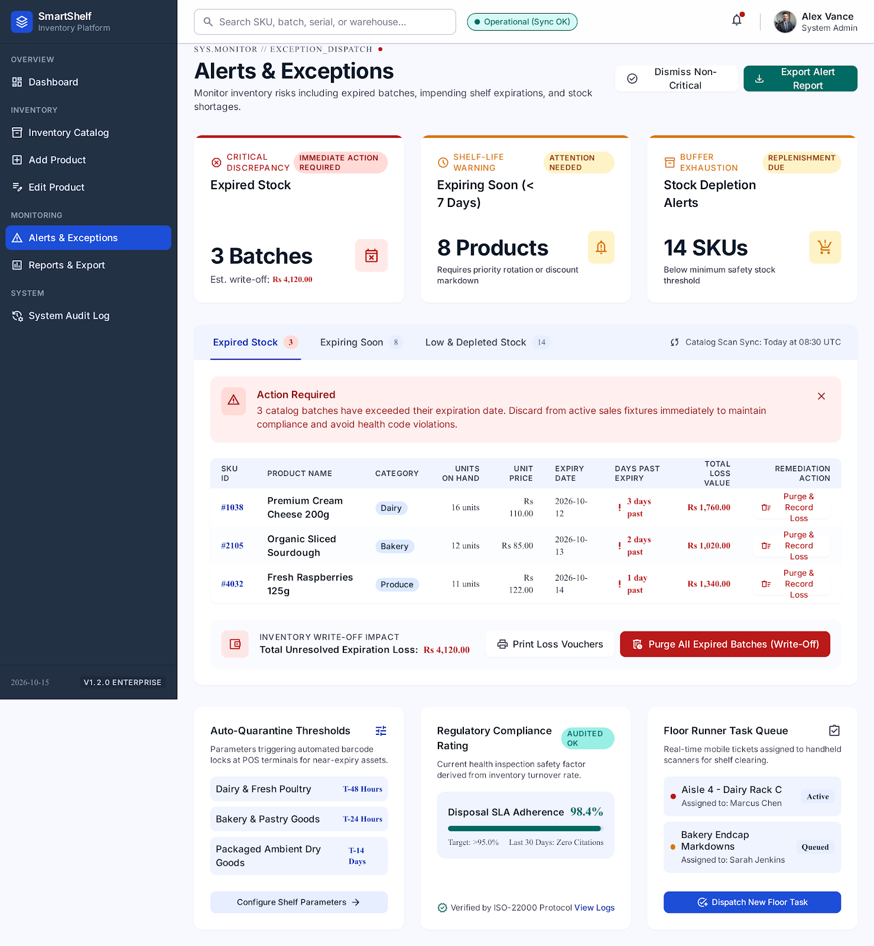
Screenshot 4.3.1: Alerts & Expiration Exception Hub Displaying Imminent Expiry and Low-Stock Batches
The Reports and Data Export Center summarises inventory stock distribution across categories and facilitates CSV/JSON data auditing.
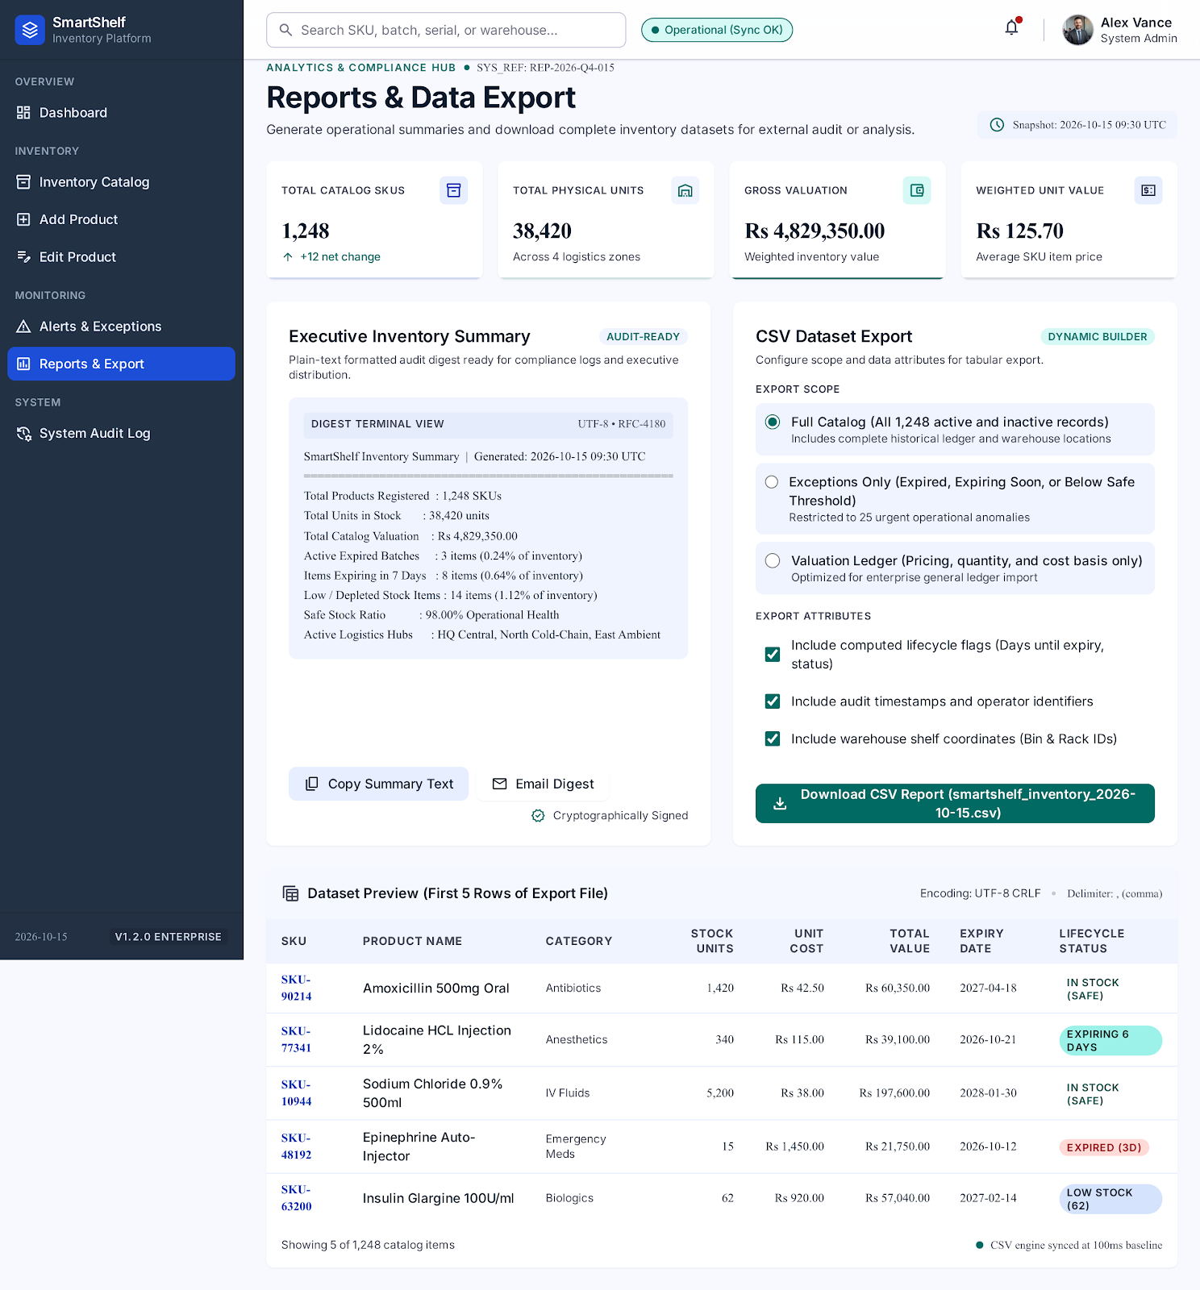
Screenshot 4.3.2: Category Stock Distribution and Data Export Center

4.3.3 ACTIVITY DIAGRAM
Figure 4.3 shows the flow of the inventory analysis. Product records are retrieved from the database and each record is checked against the expiry and stock rules. The resulting alerts and summary values are then displayed to the user.
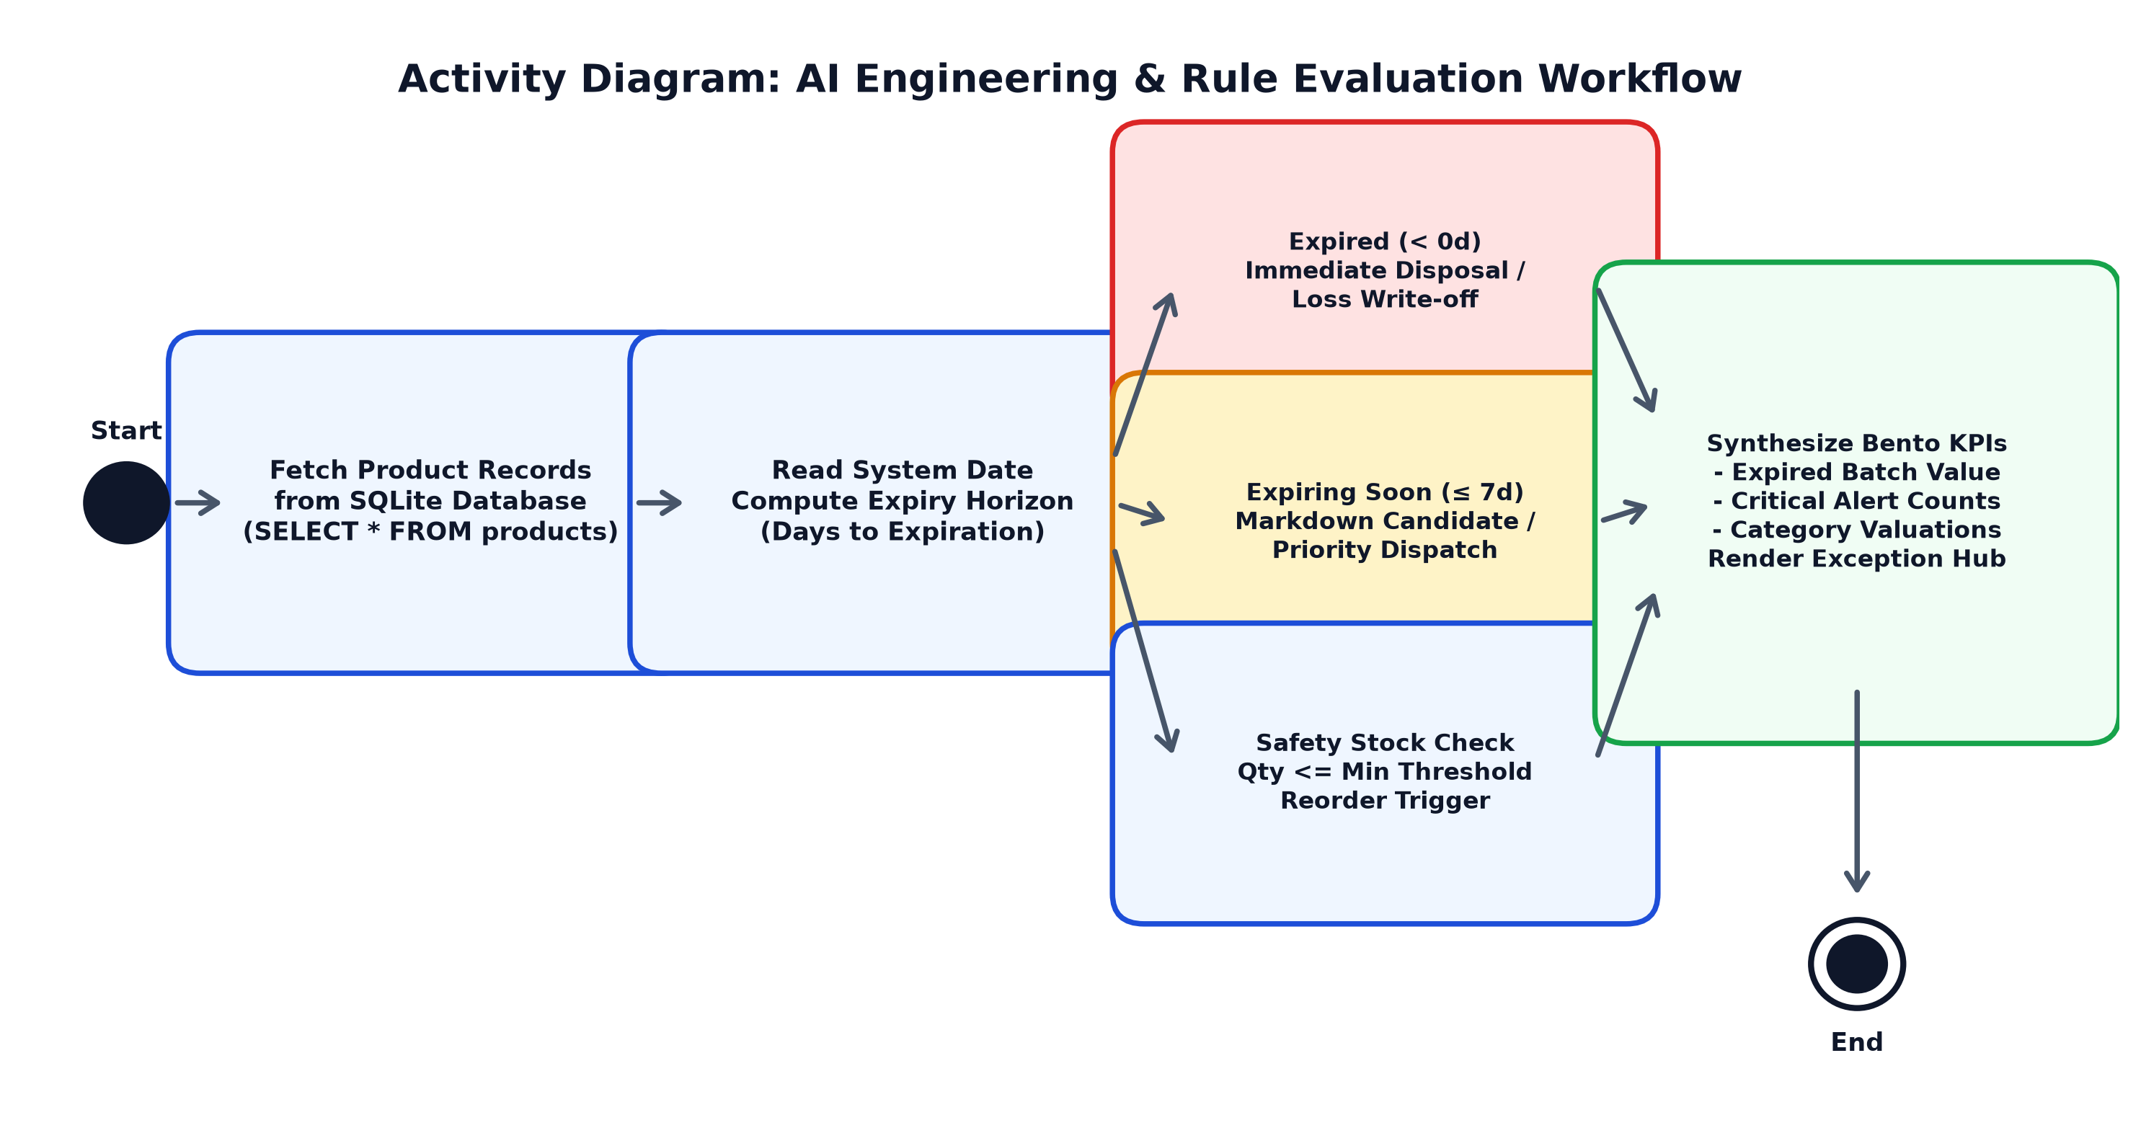
Figure 4.3: Activity Diagram for AI Engineering
Explanation of the Activity Flow
- Each expiry date and quantity is compared with the current date and minimum stock level.
- The rules assign a status to every product and summary counts are calculated.
- The tables, metrics, and charts are displayed to the user.

4.3.4 RESULT OF AI ENGINEERING
The inventory analysis module identifies expired products, products approaching expiry, and items with insufficient stock. It displays alerts and summary information to help users monitor inventory efficiently. The current implementation uses rule-based intelligence and does not require machine-learning training.

MODULE 4

SECURITY ENGINEERING

4.4.1 PROCEDURE FOR SECURITY ENGINEERING
The Security Engineering module focuses on protecting inventory records from invalid input and unauthorized changes. It incorporates basic validation and access-control practices appropriate for a small inventory application. The steps followed are:
- Validate product names, quantities, prices, and expiry dates before storing records.
- Reject negative quantities and invalid prices.
- Use parameterized SQL queries when inserting, updating, or deleting records.
- Use a login mechanism if the application requires user authentication.
- Restrict inventory modification functions to authorized users when login is implemented.
- Display clear error messages without exposing database details.
- Maintain database backups to reduce the risk of data loss.
- Test invalid inputs and unauthorized access scenarios.
The validation rules applied to each input are summarised in Table 4.6.
Input | Validation Rule | Action on Failure
Product name | Must not be empty | Show "Product name is required"
Quantity | Must be a whole number greater than or equal to 0 | Reject and show an error message
Price | Must be a number greater than or equal to 0 | Reject and show an error message
Expiry date | Must be a valid calendar date | Reject and request a valid date
Table 4.6: Input Validation Rules
Parameterized queries prevent SQL injection because user input is passed as data and never joined into the SQL text:
cursor.execute(
"INSERT INTO products (product_name, category, quantity, price, expiry_date)"
" VALUES (?, ?, ?, ?, ?)",
(name, category, qty, price, expiry))
Security Test Cases
Test Case | Input | Expected Result
Empty product name | Name left blank | Error: product name is required
Negative quantity | Quantity = -5 | Entry rejected with an error message
Invalid price | Price = abc | Entry rejected with an error message
SQL injection attempt | Name = ' OR 1=1 -- | Stored as plain text; no query is altered
Unauthorized edit | Edit without login | Operation denied
Table 4.7: Security Test Cases

4.4.2 SCREENSHOTS FOR SECURITY ENGINEERING
The following screenshots can be included after implementation:
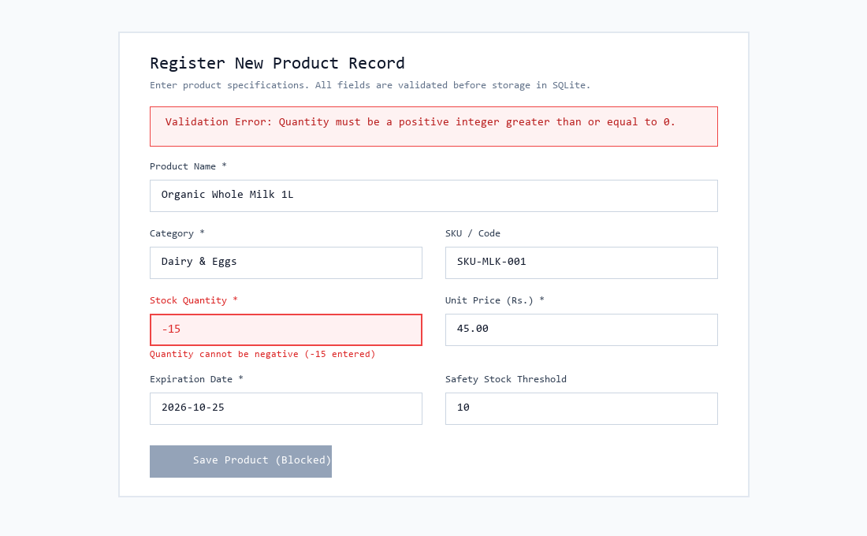
Screenshot 4.4.1: Input Validation Error Rejection for Negative Quantity
An input validation error notification appears when an invalid or negative quantity is entered, safely rejecting invalid submissions.
The system audit log provides an immutable governance ledger tracking all user actions (ADD, EDIT, DELETE) with complete timestamps and parameterised query protection.
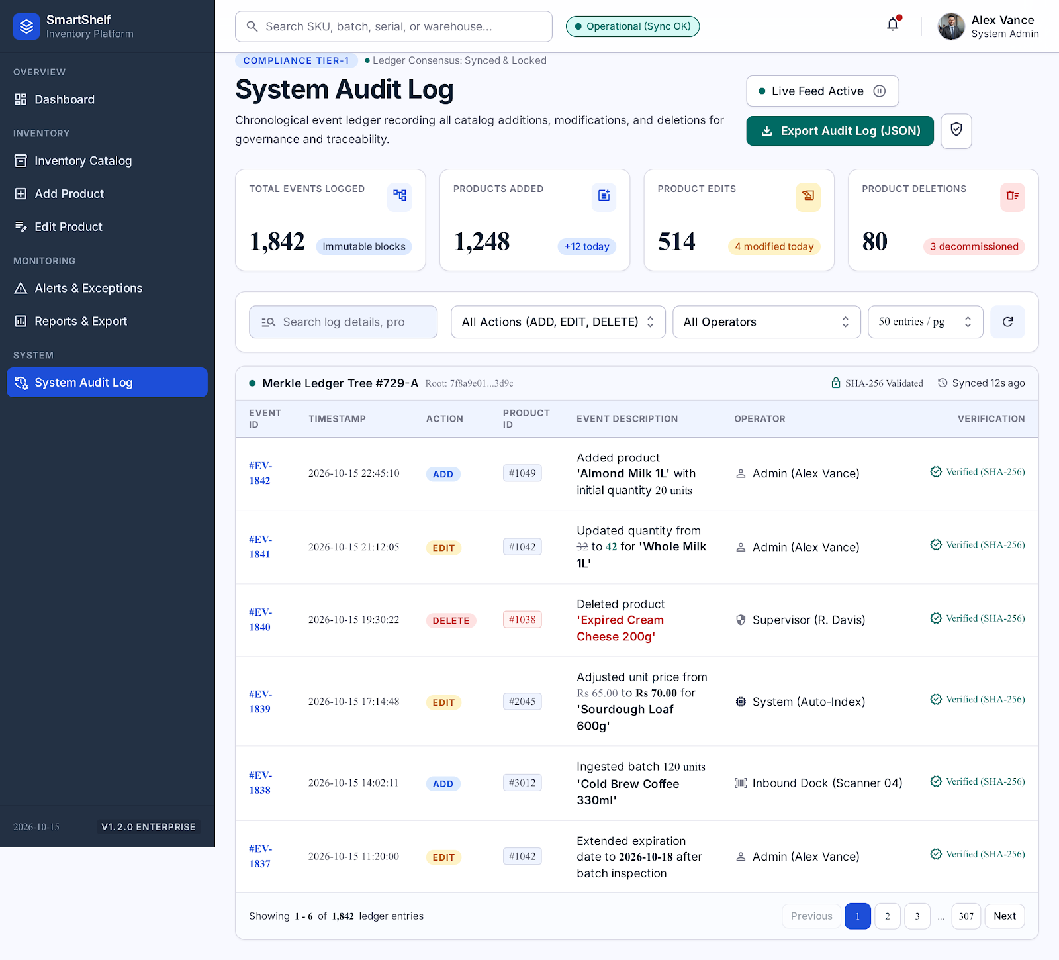
Screenshot 4.4.2: System Audit Log & Governance Ledger Tracking Secure Operations

4.4.3 ACTIVITY DIAGRAM
Figure 4.4 shows the security flow. Every request is first validated. If authentication is required, the user's authorization is checked before the operation is executed. If validation fails or the user lacks permission, the system rejects the operation and displays an appropriate message; otherwise the data is saved and a confirmation is shown.
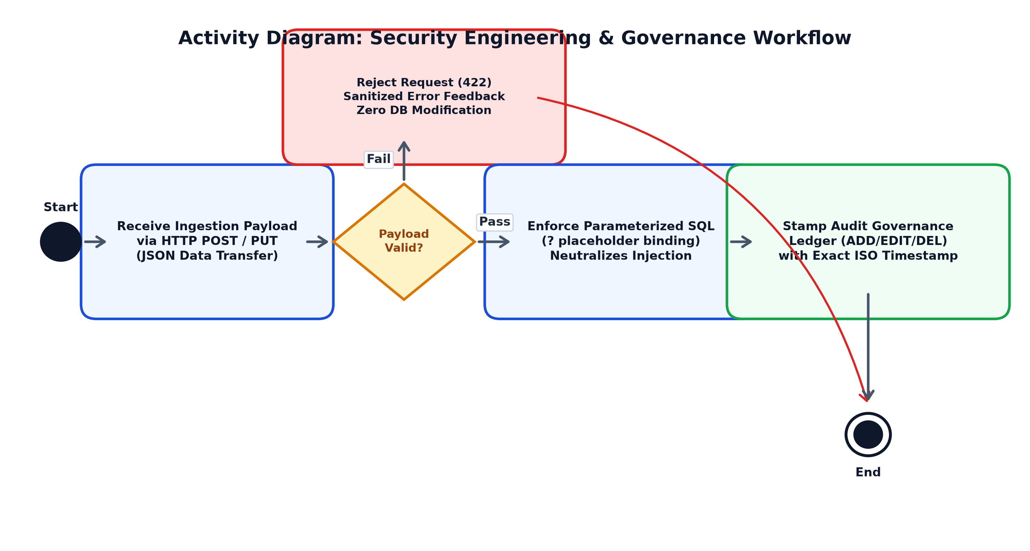
Figure 4.4: Activity Diagram for Security Engineering
Explanation of the Activity Flow
- The application receives the data entered by the user.
- The input is validated for type, range, and completeness.
- If authentication is enabled, the user's permission is checked.
- A permitted operation is executed with a parameterized SQL query and a confirmation is displayed.
- Invalid or unauthorized requests are rejected with a clear message.

4.4.4 RESULT OF SECURITY ENGINEERING
The Security Engineering module protects inventory records from malformed input, SQL injection, and unauthorized tampering. All database modifications are executed via parameterized SQL queries with strict Pydantic validation, while the immutable System Audit Log maintains an event ledger tracking every addition, edit, and deletion with zero exposure of internal database errors to end users.
Good Practices Followed

CONCLUSION
SmartShelf — Intelligent Inventory and Expiry Management System provides a simple and practical approach to managing product inventory. The application combines a Streamlit-based user interface, Python processing, and an SQLite database to maintain product records efficiently.
The system supports product addition, modification, deletion, and viewing. It also identifies products that are expired or approaching expiry and generates low-stock warnings based on predefined rules. Inventory summaries and reports help users understand stock availability and identify products that require attention.
The proposed solution can reduce the manual effort involved in inventory management and help small businesses minimize avoidable product wastage. The use of Python and SQLite makes the system easy to develop, test, and maintain.
Future Enhancements
In the future, SmartShelf can be enhanced with the following features:
- Barcode scanning for faster product entry and stock updates.
- Supplier management and purchase order tracking.
- Automated notifications through email or messaging services.
- Multi-user access with different roles.
- Cloud database integration for reliable online storage.
- Machine-learning-based demand forecasting.
Project Outcomes
The project demonstrates how modern, freely available tools can solve a practical business problem. Working on SmartShelf involved database design, user interface development, rule-based analysis, deployment planning, and secure coding, which together show how the four engineering disciplines combine in one application.

REFERENCES
- Python Software Foundation, Python Documentation, https://docs.python.org/3/
- Streamlit, Streamlit Documentation, https://docs.streamlit.io/
- SQLite, SQLite Documentation, https://www.sqlite.org/docs.html
- Pandas, Pandas Documentation, https://pandas.pydata.org/docs/
- GitHub, GitHub Documentation, https://docs.github.com/

